


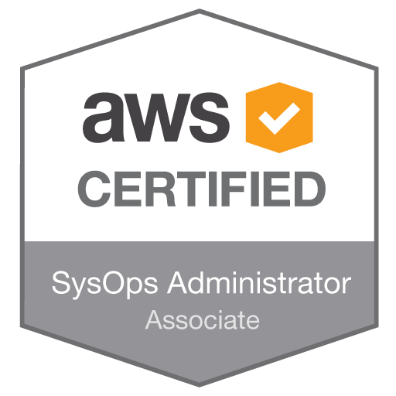

Adil Jafry
4788 Fulwell Rd
Mississauga, ON
L5M7J7
(647) 894-9311
Email: adil.jafry@gmail.com

January 30, 2018

RE: SP2016-56-4 Solution Architect - Take Home Assignment

Hello Ted & Sriju,

I wanted to take a moment to thank you for considering me for the exciting opportunity at WSIB and the time you spend with me on telephone and onsite interviews.

I welcome the opportunity you provided me by giving the take home assignment to further demonstrate my technical skills for the solution architect role.

I am enclosing outcome of my assignment. Please feel free to call me if you need additional information, or have any questions.

Thank you again for your time, and I look forward to hearing from you.

Sincerely,

Adil Jafry

Requirements:

- Create a highly available Kubernetes cluster on Azure cloud platform
- Deploy Book Info app on your cluster
- Integration your book info app with istio, prometheus and jaeger within istio for distributed tracing.
- Write a script to create load on your book info app, so that we could view the metrics on jaeger and prometheus dashboards
- Configure Istio for mutual authentication between microservices in book info app.
- Install and configure confluent kafka platform on Azure cloud
- Create a Helm chart for any application of his choice
- Explain each component/product used
- Upload all your source to GitHub and share the repo to srijunairwsib
- Share public IP/URL for your apps and dashboards

Deployed Kubernetes cluster under resource group K8RG

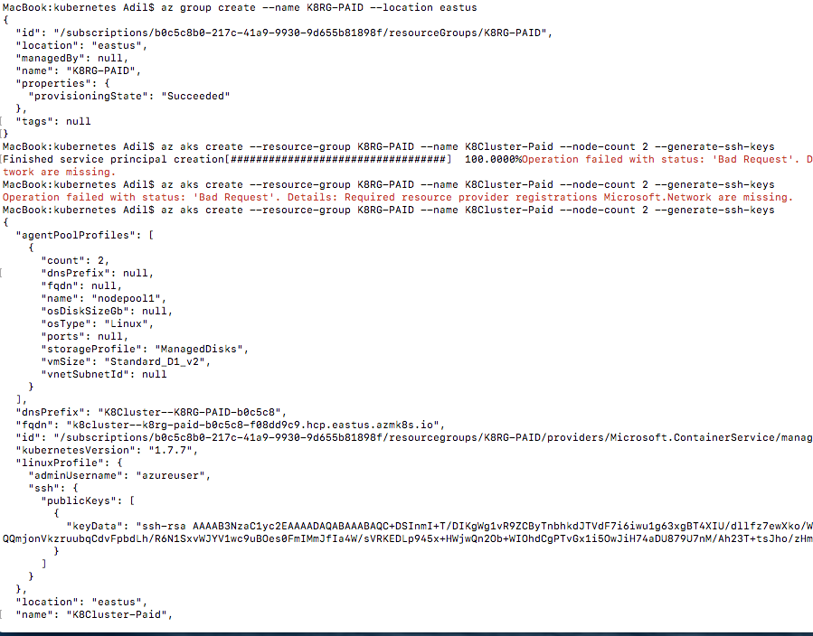

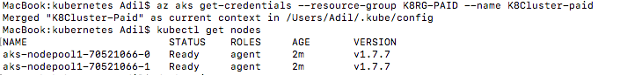

Istio

Downloaded and extracted latest istio files from the link curl -L https://git.io/getLatestIstio | sh- and Installed ISTIO

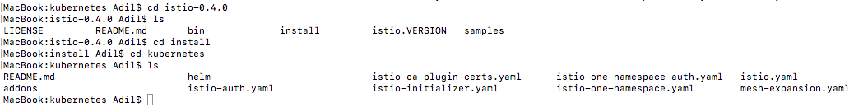

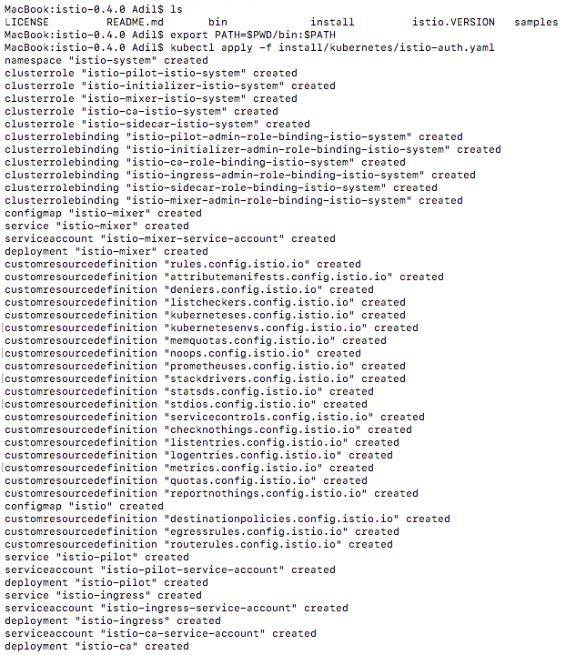

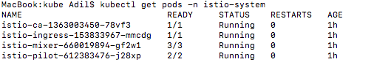

Deployed the Bookinfo Application modified yaml file to 2 replicas instead of 1

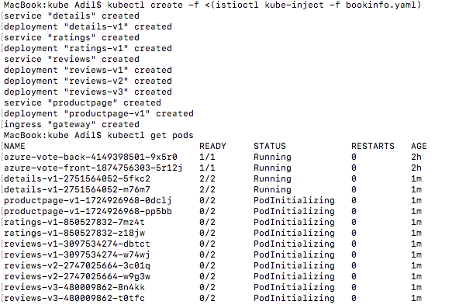

Installed addons – Prometheus, Grafana, Zipkin and Servicegraph

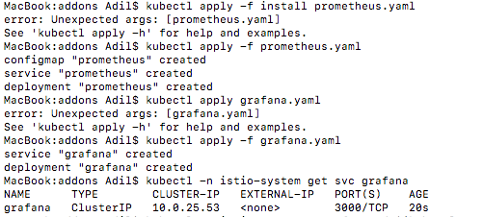

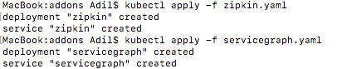

Bookinfo application with Grafana updating metrics

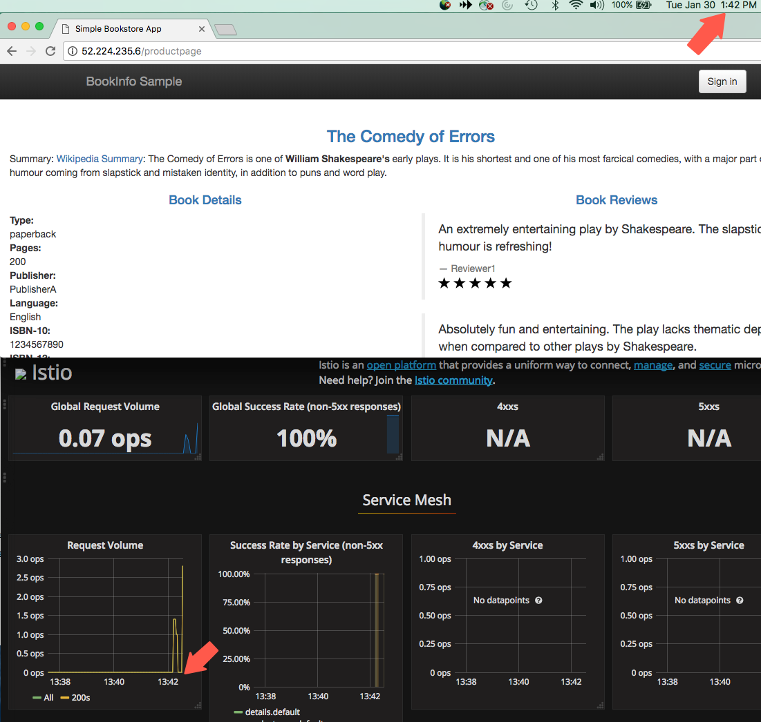

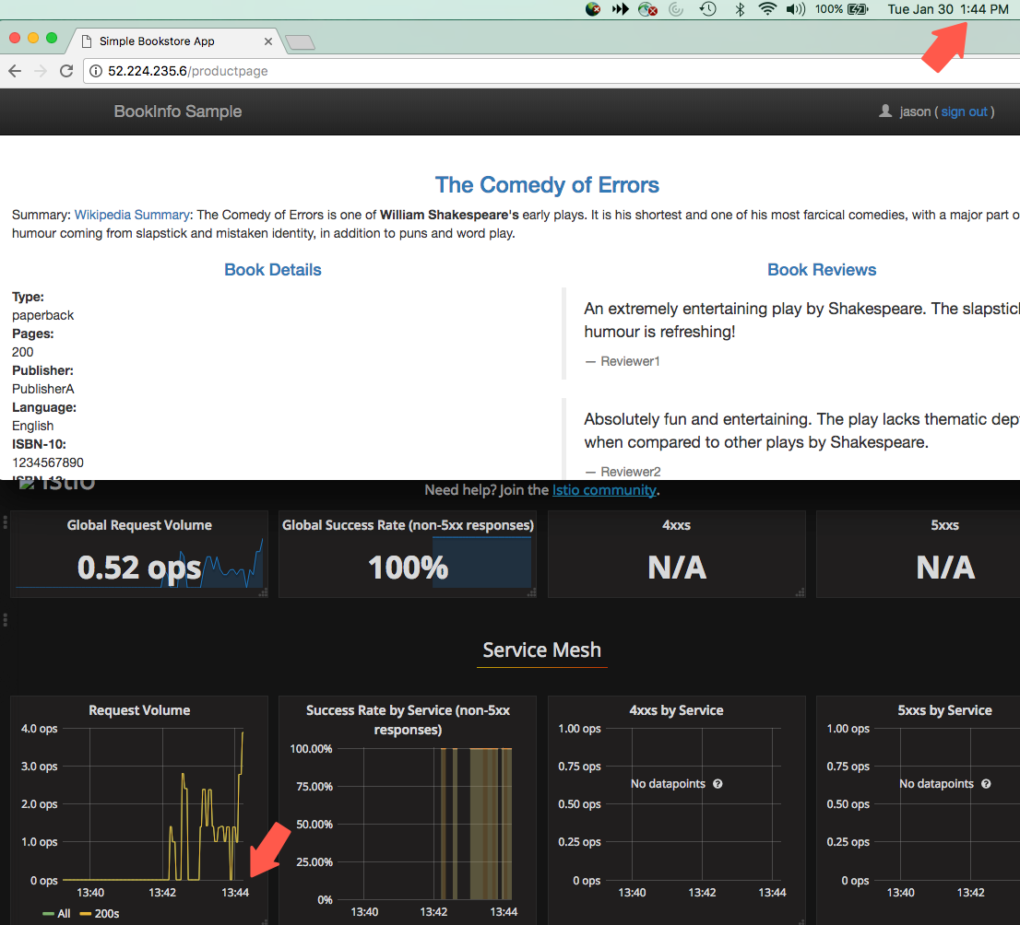

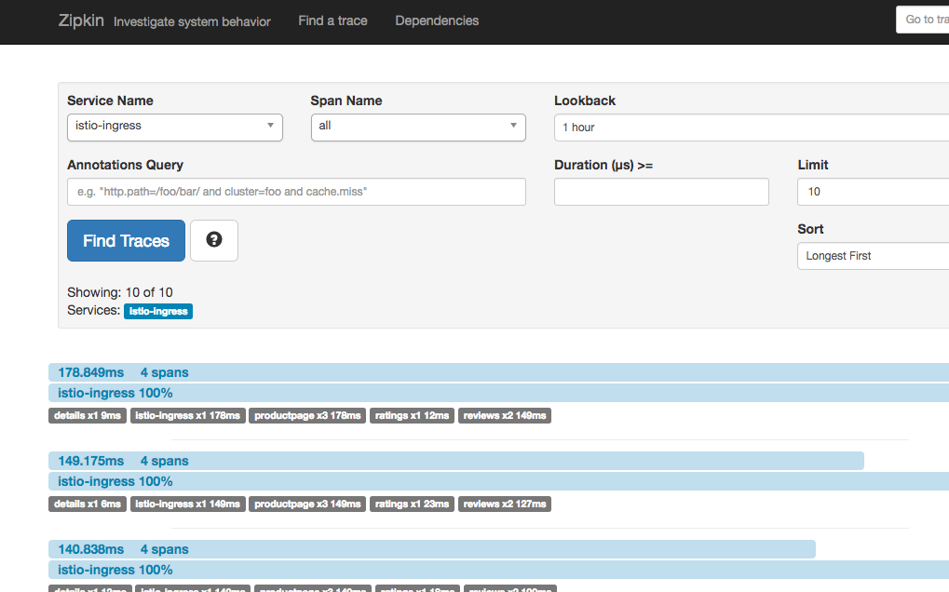

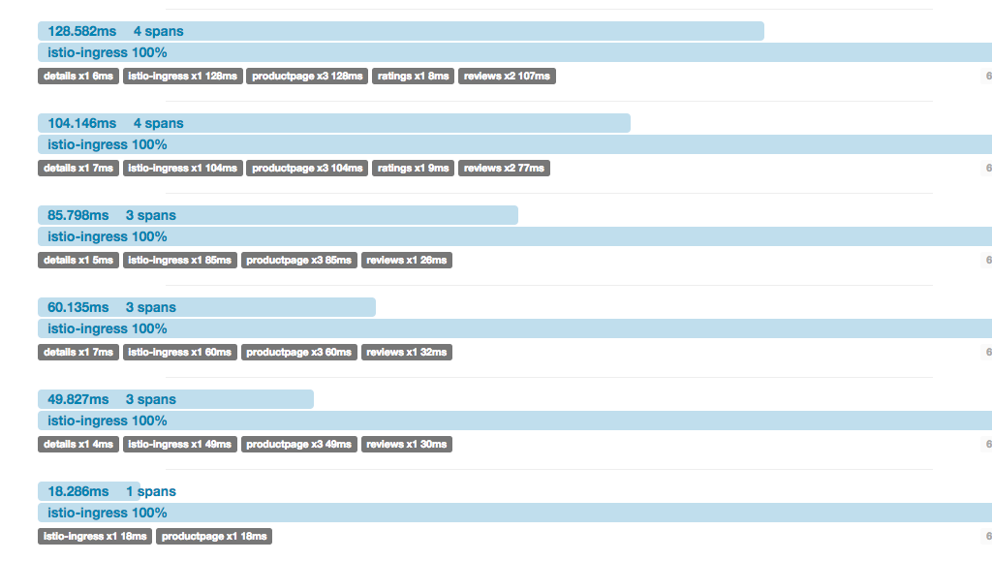

Created helm chart called mychart and modified values.yaml file to add sample todo application

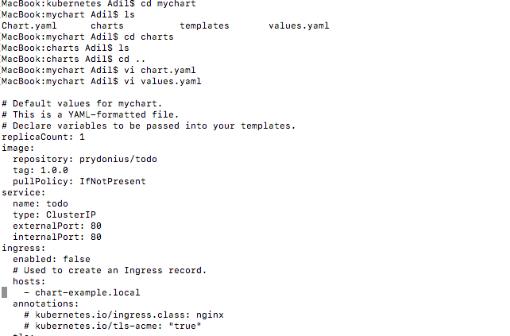

Deployed the application using HELM chart

